WEEK 2 PROJECT
Advanced Data Visualization and Storytelling with Python
Project: Wine Data Story – Turning Chemical Measurements into Visual Insights
Dataset: UCI Wine Dataset | Domain: Data Science / Scientific Data Analysis | Tools: Python, Pandas, NumPy, Matplotlib, Scikit-learn

1. Introduction
This Week 2 project extends the Week 1 data-preparation workflow into advanced visualization and data storytelling. The objective is to create a coherent visual narrative that a non-technical audience can understand. The UCI Wine dataset is used because it contains multiple chemical measurements for three wine cultivars, allowing the analysis to move from individual distributions to relationships and finally to multi-feature class profiles.

2. Storytelling Question
The central question is: How do the chemical characteristics of the three wine classes differ, and which relationships or combinations of features are useful for understanding those differences?
The story follows five stages: understand alcohol distributions; examine a two-variable relationship; compare the spread of key variables; investigate correlations across the feature set; and summarize each class using a multi-feature profile.

3. Dataset and Preparation
The dataset contains 178 observations, 13 numeric chemical features and a target representing three wine classes. It was loaded using scikit-learn. No missing values or duplicate rows were present in the loaded dataset. A readable class_name column was added. Standardization was used only where variables with different units needed to be compared visually.
Core code:
from sklearn.datasets import load_wine
wine = load_wine(as_frame=True)
df = wine.frame.copy()
df['class_name'] = df['target'].map(dict(enumerate(wine.target_names)))

4. Visualization 1 – Violin Plot
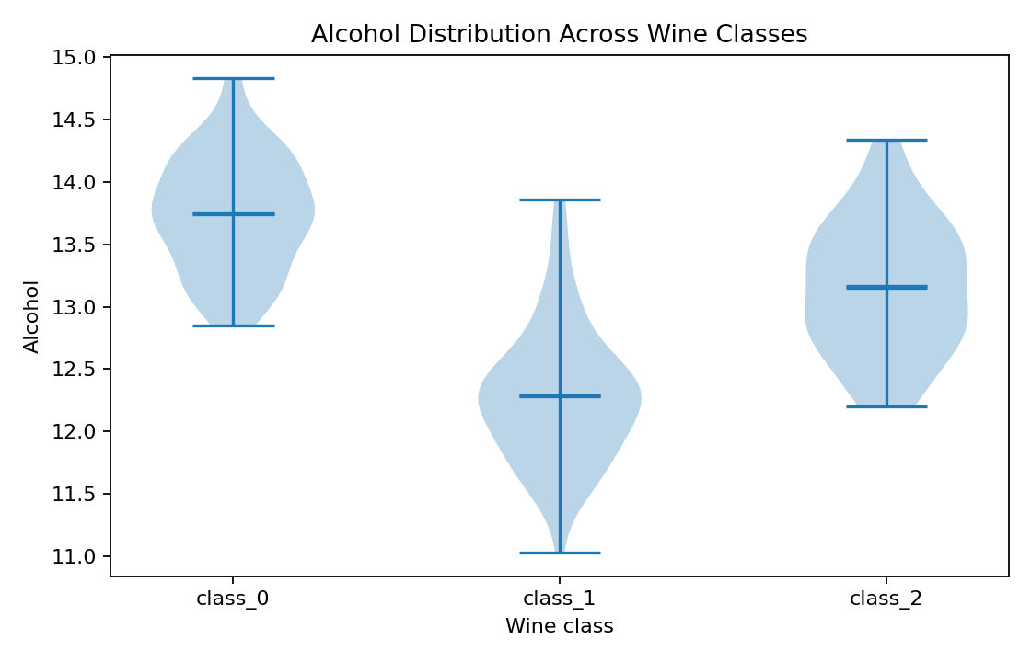
Figure: Alcohol Distribution Across Wine Classes.
Why this visual was chosen: A violin plot was selected because it shows distribution shape, central tendency and spread. The chart starts the story by asking whether alcohol distributions differ between classes.
Key insight: The distributions are not identical across classes, so alcohol contains class-level information. However, overlap remains, meaning alcohol alone should not be treated as a perfect classifier.

5. Visualization 2 – Scatter Plot
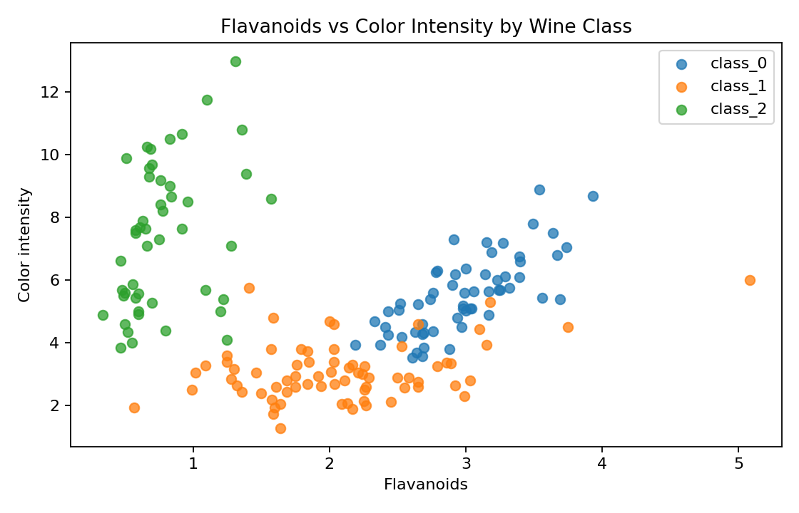
Figure: Flavanoids vs Color Intensity by Wine Class.
Why this visual was chosen: A scatter plot was selected to show the relationship between two continuous variables while using class labels to reveal group structure.
Key insight: The Pearson correlation between flavanoids and color intensity is -0.172. The class groups also occupy different regions of the feature space, suggesting that combinations of measurements can be more informative than a single variable.

6. Visualization 3 – Standardized Box Plot
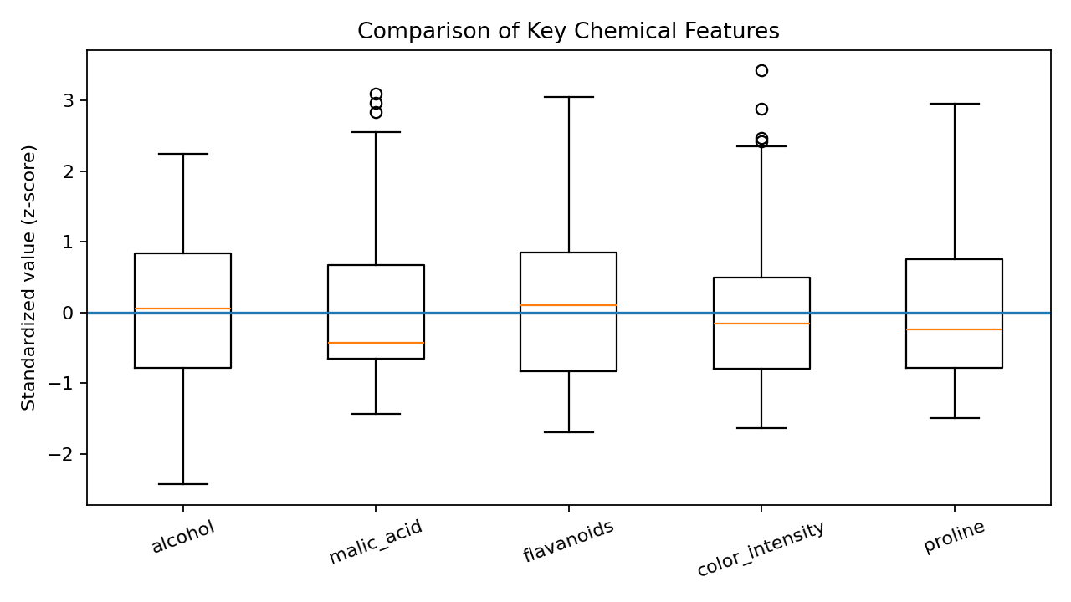
Figure: Comparison of Key Chemical Features.
Why this visual was chosen: A standardized box plot allows variables with different measurement scales to be compared on a common relative scale.
Key insight: The distributions have different levels of spread and several observations lie beyond the whiskers. These observations should be investigated rather than automatically deleted.

7. Visualization 4 – Correlation Heatmap
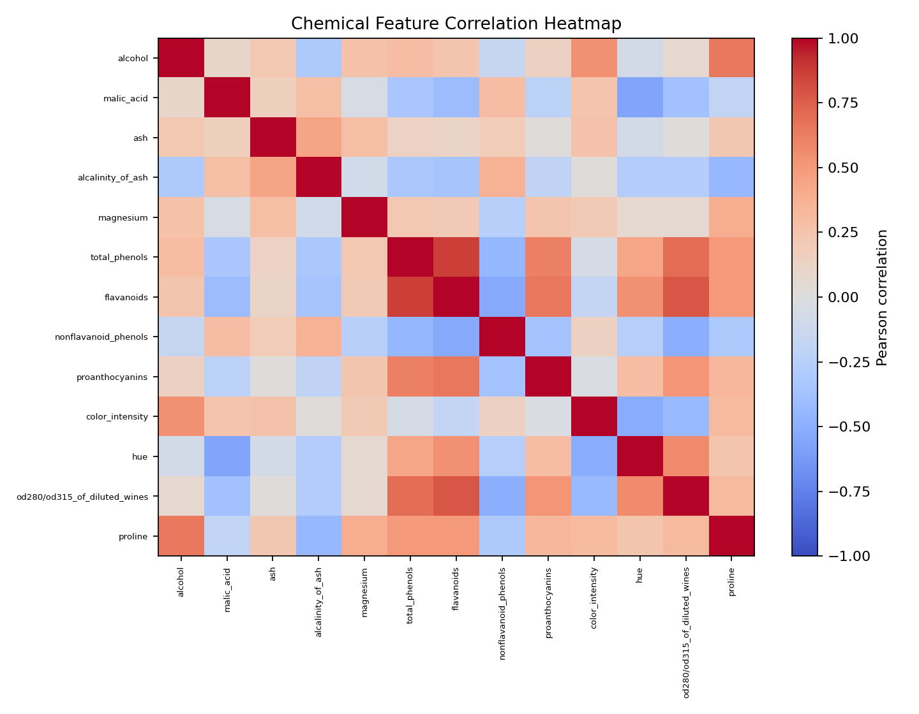
Figure: Chemical Feature Correlation Heatmap.
Why this visual was chosen: A heatmap summarizes many pairwise relationships in one visual and makes strongly related feature groups easier to identify.
Key insight: Several chemical measurements show strong relationships, while others are weaker or inverse. This suggests possible redundancy and motivates future feature-selection or dimensionality-reduction analysis.

8. Visualization 5 – Multi-Feature Class Profile
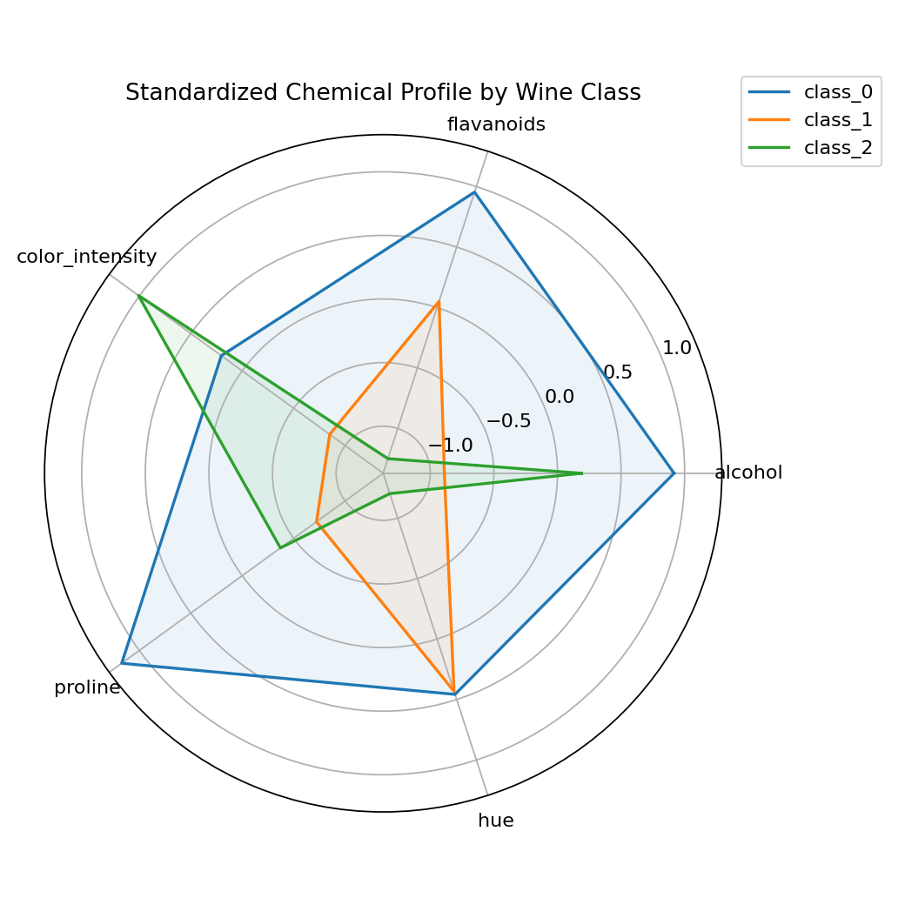
Figure: Standardized Chemical Profile by Wine Class.
Why this visual was chosen: The profile chart provides a summary view by comparing several standardized characteristics simultaneously.
Key insight: The three classes form visibly different overall profiles. This supports the conclusion that the classes are characterized by combinations of chemical measurements rather than one isolated property.

9. Overall Data Story
The narrative progresses from a single-variable distribution to a two-variable relationship, then to multi-variable comparison and finally to a synthesized class profile. The main message is that the dataset contains meaningful structure: classes differ in their distributions, features are related, and combinations of measurements provide a richer description than individual variables.

10. Business and Scientific Implications
Scientifically, the results suggest that chemical measurements can support studies of wine-group differences and guide follow-up experiments. Strong relationships among features may indicate overlapping chemical information and can guide feature-selection studies.
From a business perspective, chemical profiles could support quality-control analytics, product classification, laboratory reporting and decision-support systems. These descriptive findings should not be treated as a production classifier without domain validation, representative samples and independent test data.

11. Visualization Design Principles
• Use the simplest chart that answers the specific question.
• Keep class labels consistent across visuals.
• Give every figure a clear title, axis labels and caption.
• Standardize variables when direct comparison across different units is required.
• Use grouping and visual encoding consistently.
• Avoid causal claims from correlation alone.
• Build the story from simple observations toward a synthesized conclusion.

12. Conclusion
This Week 2 project demonstrates advanced visualization and data storytelling with Python. Five complementary visualizations explain distributions, relationships, variability, correlations and multi-feature profiles. Together they transform a numerical dataset into a clear sequence of evidence and insights suitable for both technical and non-technical audiences.

13. References
UCI Machine Learning Repository – Wine Dataset, Dataset ID 109.
Scikit-learn documentation – load_wine dataset loader.
Matplotlib documentation – visualization and plotting.

